HEAT CALCULATOR

**PROJECT PARTNERS:**

* S.M Anas - 10077
* Syed Salman Abbas - 10089
* Rao Ammar Luqmaan - 10082

**PROJECT Calculations:**

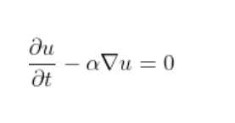

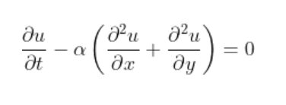

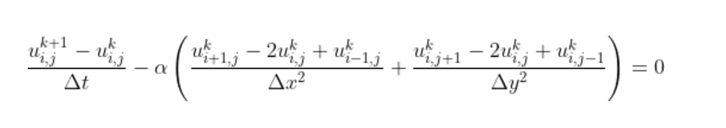

**FINAL EQUATION:**

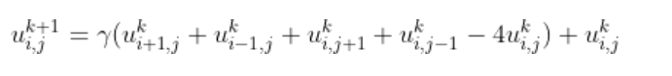

**Where:**

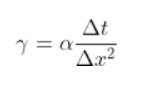

**Calculations link:**

[**https://levelup.gitconnected.com/solving-2d-heat-equation-numerically-using-python-3334004aa01a**](https://levelup.gitconnected.com/solving-2d-heat-equation-numerically-using-python-3334004aa01a)